KJ COLLEGE OF ENGINEERING AND MANAGEMENT RESEARCH, PUNE
Department of Computer Engineering
“Smart Cng Reservation System”
Group members- Prathamesh Gaikwad , Shreyash Jangam , Kadambari Kale, Sujit Kale

ABSTRACT: The rapid increase in Compressed Natural Gas (CNG) vehicles has led to heavy congestion at CNG filling stations. Long queues result in time wastage, traffic blockage, and inefficient station operations. This paper presents a Smart CNG Reservation System that enables vehicle owners to book CNG fueling slots in advance through a web or mobile application. The system provides real-time slot availability, secure user authentication, reservation management, and an admin panel for station control. The proposed solution reduces waiting time, improves station utilization, and enhances user convenience.
INTRODUCTION: CNG is widely used as a clean and economical fuel for vehicles. However, increasing demand has caused overcrowding at fueling stations, especially during peak hours. Current fueling methods follow a first-come-first-serve approach without prior scheduling, leading to long waiting times. A digital reservation platform can effectively manage queues and improve fueling efficiency.
SCOPE AND METHODOLOGY: The scope of the system is to provide an online platform for CNG slot booking to reduce station congestion and improve customer experience. The system includes user registration, real-time slot display, booking confirmation, and station administration modules. The methodology involves developing a web-based application connected to a centralized database. Users log in, select a nearby CNG station, view available time slots, and confirm reservations. The server verifies slot availability,
RESULTS & EXPECTED PERFORMANCE: The implementation of the Smart CNG Reservation System is expected to significantly reduce waiting time at CNG stations. Organized slot scheduling minimizes queue length and prevents traffic congestion near fueling points. Station managers gain better control over fuel distribution and peak-hour demand. The system improves customer satisfaction by offering a predictable and time-saving fueling experience.

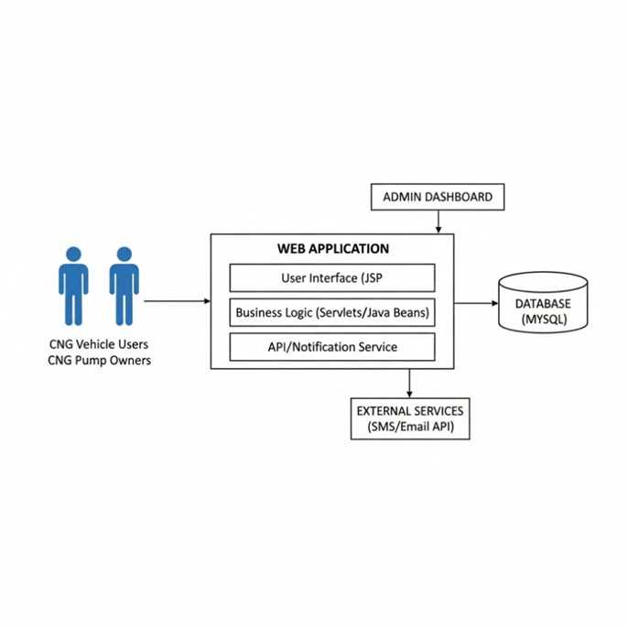
CONCLUSION: The Smart CNG Reservation System provides an effective solution to the growing problem of congestion at CNG fueling stations. By introducing advance slot booking and digital queue management, the system improves fuel station efficiency and user convenience. The proposed model supports smart transportation initiatives and can be scaled for multiple stations in urban environments.
REFERENCES: [1] IEEE Smart Transportation Systems Literature, 2023.
[2] Fuel Station Queue Management Research, Journal of Transportation, 2022.
[3] Web-Based Reservation System Design Studies, 2024.

